Practical #3
Practical Title:
To apply GitHub-based collaboration techniques including branching and merging
Theory:
1. What is GitHub Collaboration?
GitHub collaboration is the process where multiple developers work together on the same project by sharing code, tracking changes, reviewing contributions, and managing versions using repositories, branches, and pull requests
2. What is Branching in Git?
Branching is the process of creating a separate line of development in a repository. It allows developers to work on new features or bug fixes without affecting the main code.
3. What is Merging?
Merging is the process of combining changes from one branch into another, usually from a feature branch into the main branch.
4. What is Pull Request (PR)?
A Pull Request (PR) is a feature in GitHub where a developer requests to merge changes from one branch into another. It allows team members to review, discuss, and approve changes before merging.
Procedure:

Step 1: Create a GitHub Repository
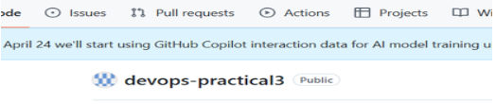
Step 2: Clone Repository
Step 3: Create a New Branch
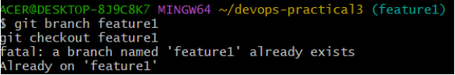
Step 4: Make Changes and Commit
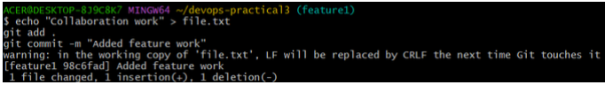
Step 5: Push Branch to GitHub
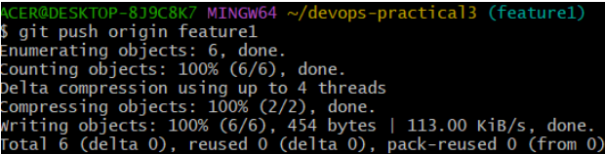

Step 6: Create Pull Request on GitHub
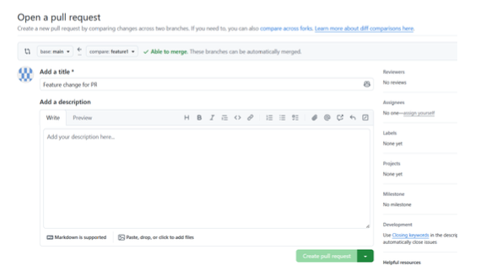
Step 7: Merge Pull Request
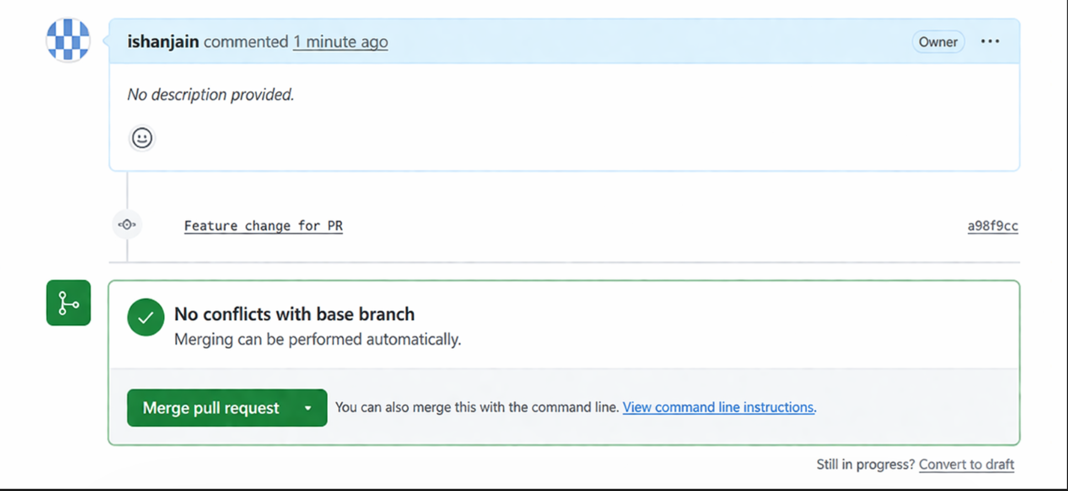
Step 8: Pull Updated Code
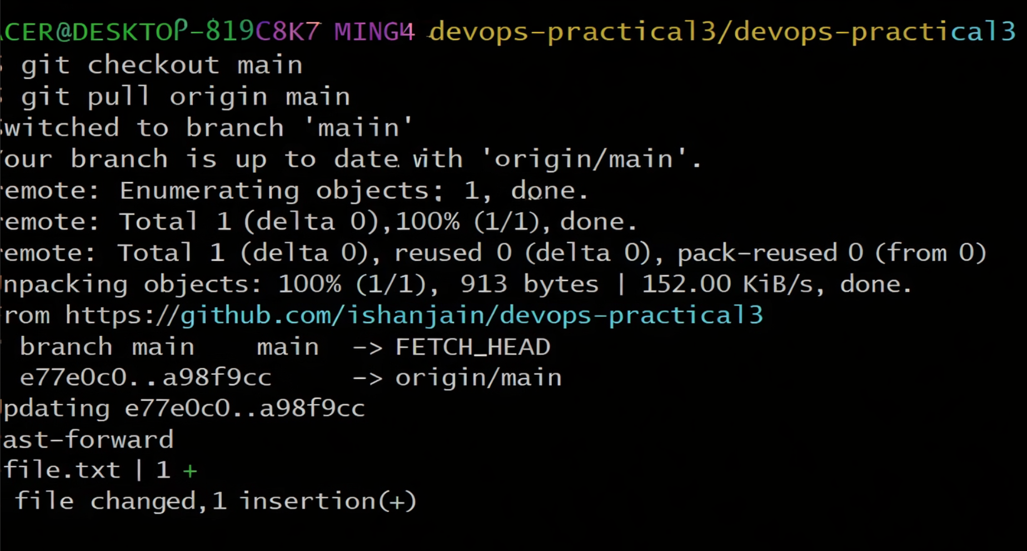

Activity / Task:
Task 1:
Create a repository and collaborate with at least one teammate.
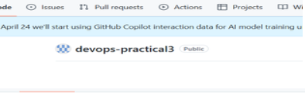
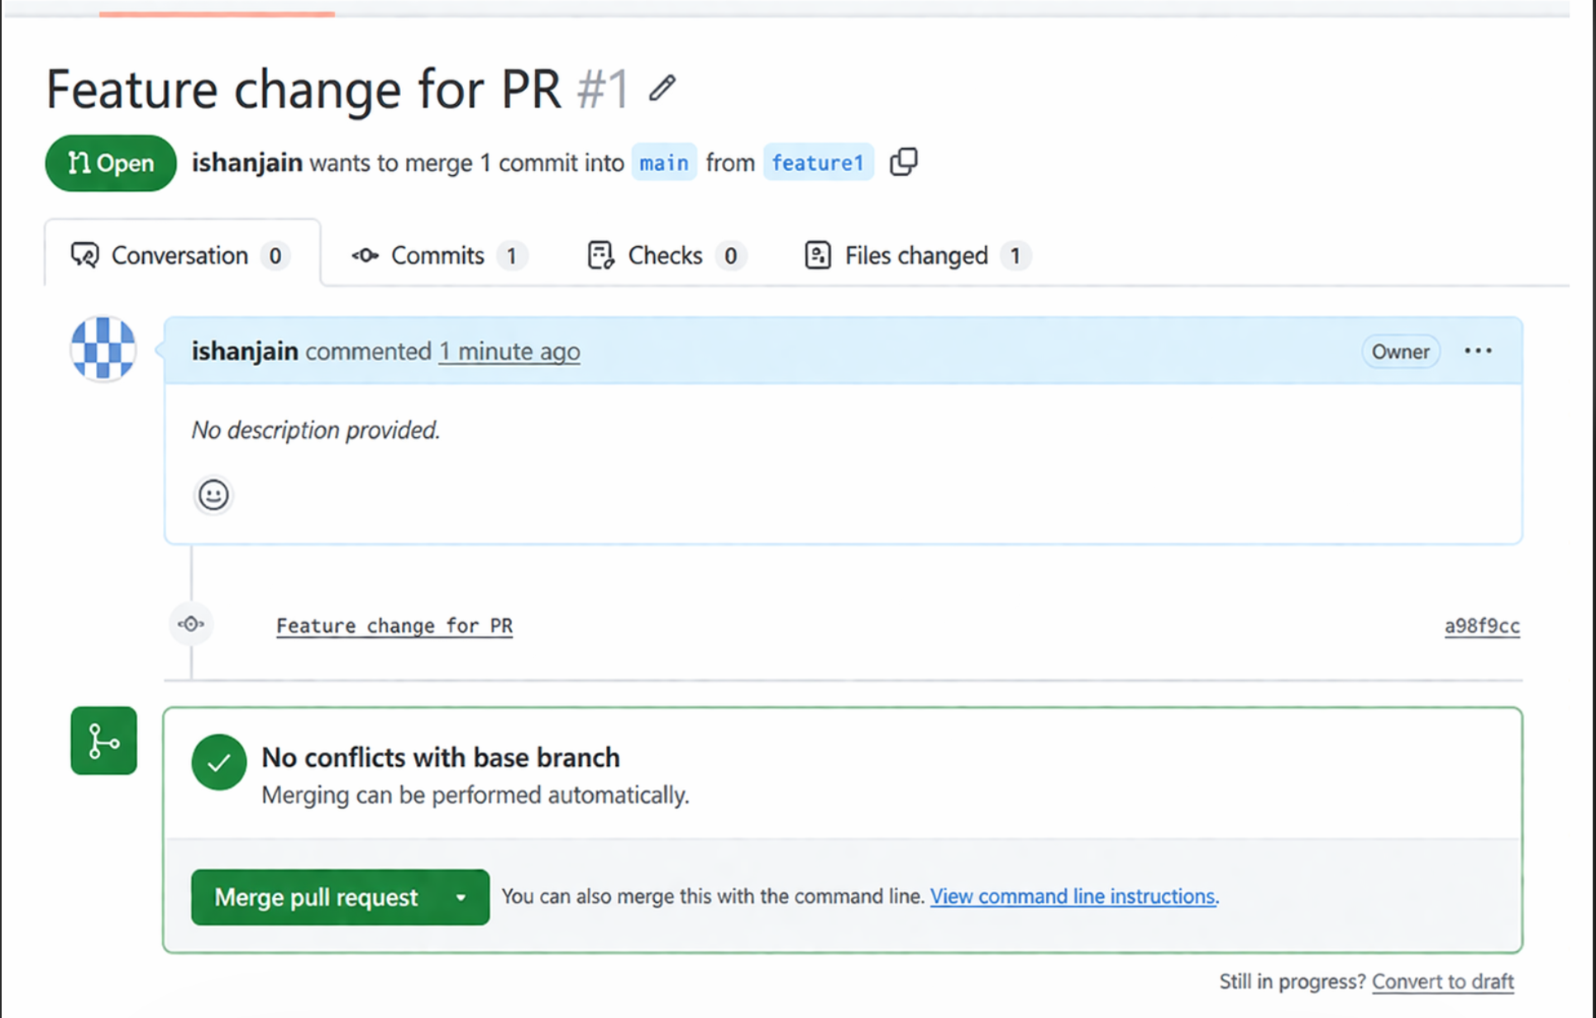
Repository Link:
https://github.com/ishanjain/devops-practical3
Task 2:
Write the steps to resolve merge conflicts.
- Pull the latest changes from the repository
- Git will show conflicting files
- Open the file and identify conflict markers:
<<<<<<< HEAD
your changes
=======
incoming changes
>>>>>>> branch-name
- Edit the file and keep the correct code
- Remove conflict markers
- Add the resolved file:
git add file.txt
- Commit the changes:
git commit -m "Resolved merge conflict"
- Push the changes:
git push
Advantages of GitHub Collaboration:
- Enables teamwork and code sharing
- Easy tracking of changes
- Code review through pull requests
- Better project management
- Supports distributed development
Challenges:
- Merge conflicts
- Requires coordination among team members
- Learning Git commands can be difficult

